SAFETY IN WORKSHOPS
Mission: You are a machine maintenance engineer. Your school is organizing an open day to present the students’ work in the workshop. You are in charge of the safety instructions for English speaking visitors…
CLIP 1: HAZARDS AND SAFETY IN A WOODSHOP
- Anticipate the possible dangers in a woodshop thanks to the chart below (columns 2 & 3). Then watch the clip to check your answers. (https://www.youtube.com/watch?v=bJbsMKRqYEY)
Hazard Analysis Worksheet
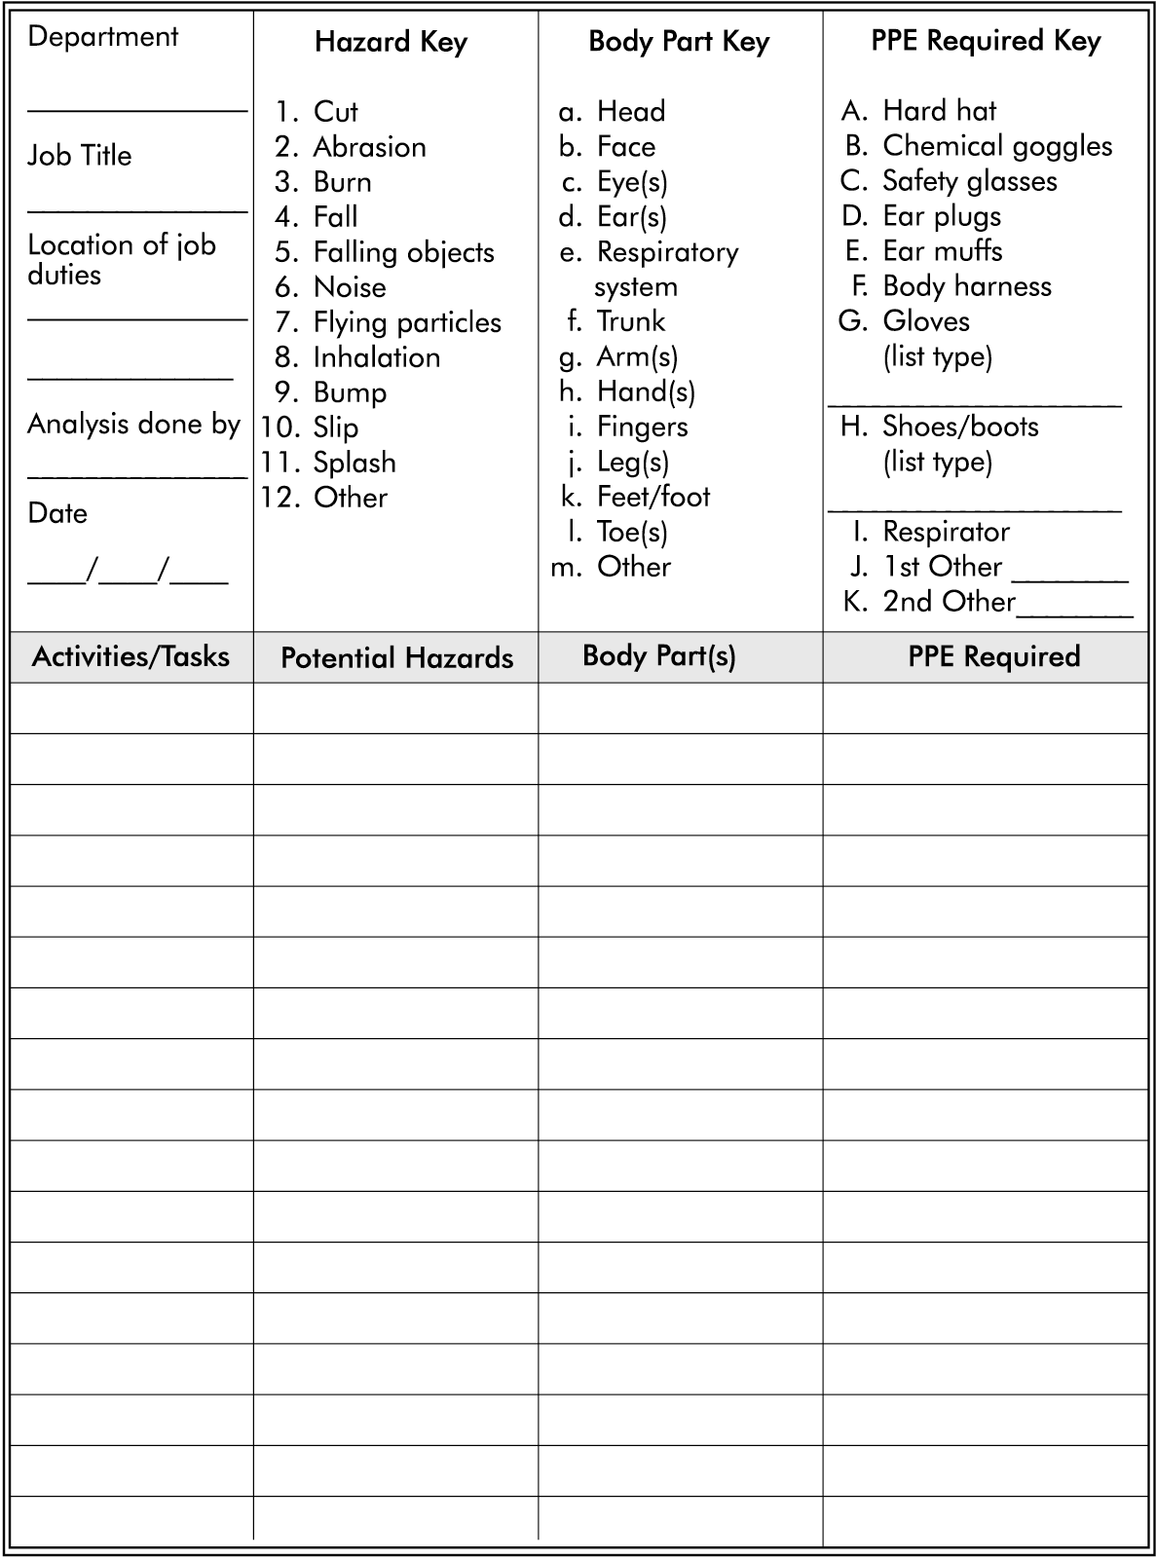
- Look at column 4,Personal Protective Equipment (PPE) and say which ones you must use in each situation.
- Note down the 6 steps of the safety plan.
- ____________________________________________________________________
- ____________________________________________________________________
- ____________________________________________________________________
- ____________________________________________________________________
- ____________________________________________________________________
- ____________________________________________________________________

CLIP 2: SAFETY EQUIPMENT
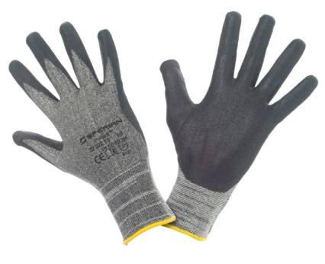
- Watch the clip and complete the visual dictionary with the names of the equipment.
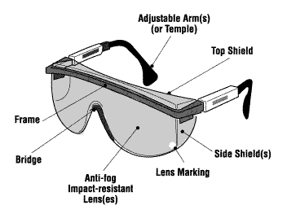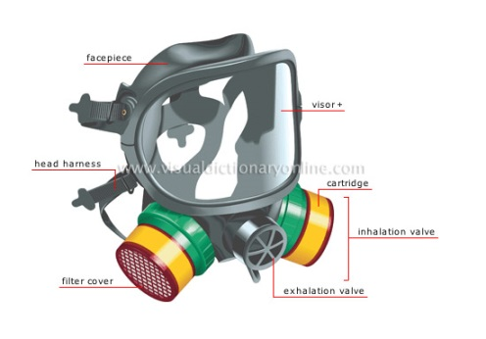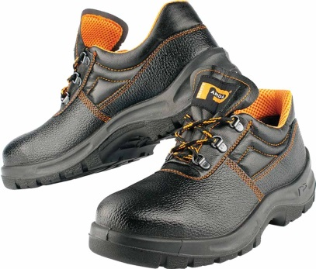

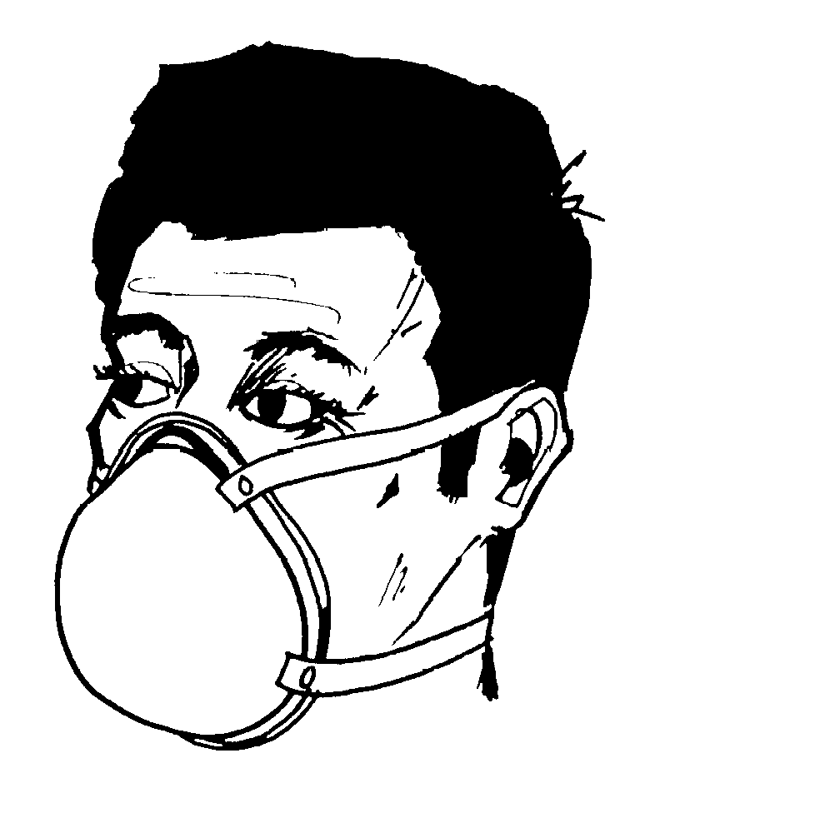
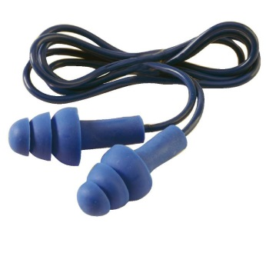

- Fill in the following definitions.

- It is probably the most important equipment. _____________________________________
- It’s needed in noisy areas. _____________________________________
- It protects from dust. _____________________________________
- It protects you from polluted environment. _____________________________________
- It protects you from very loud noises. _____________________________________
- Protects you from chemicals, stains, finishes. _____________________________________
- Protects your most vital body part from falling objects. __________________________________
- Protects the lowest part of your body from heavy objects. __________________________________

CLIP 3: CLOTHING
Watch the clip and fill in the grid with what you must or mustn’t wear and explain why.
EX.: You must wear a… because… / you mustn’t wear…because…
DO’s | DON’Ts

CLIP 4: EMERGENCIES
What is the necessary emergency equipment?

●You need a _____________________ (___________, _______________, or _____________________) with the ______________________________________________ near a 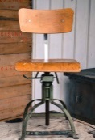.___________________________.
●Let somebody know that you 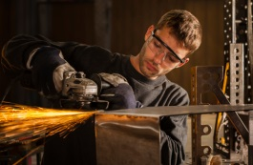_____________________________________________________.

●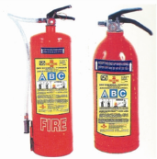_______________________________________________________________ are absolutely necessary.

●You must know where the 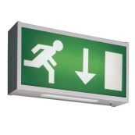___________________________________________________ are located.

●A well stacked__________________________________________________________ is also required.

VOCABULARY TEST: Voir fichier PDF “Workshop Safety Tips Puzzle”
FINAL TASKS
PARLER DES REGLES DE SECURITE DANS SON LIEU DE STAGE.
- Take a selfie and make your visitors check the errors in your equipment.
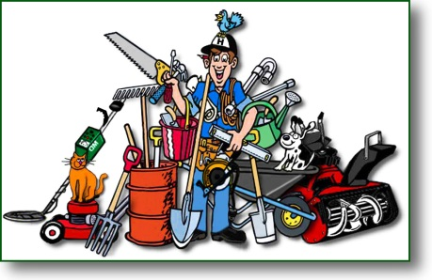

- Create a poster with what you can or can’t do in the workshop using:
Must / don’t / mustn’t / can / not allowed to /

Exemples de verbes: deteriorate the material / listen to the teacher / run in the workshop / take bad initiatives / wear safety clothes / wear trainers

