Nom de l’élève : ………………………………………………………………………………………….

Classe : ………………………………………………………………………………………………………..

Epreuve obligatoire de langue vivante étrangère au
Baccalauréat Professionnel

ANGLAIS

Evaluation en cours de formation
(CCF)

Situation A : épreuve écrite commune en trois parties
Durée 1h00

Partie 1 : Compréhension de l’oral
Titre : Lady Dinah's Emporium - London's First Cat Cafe
Déroulement :
Vous allez écouter un audio à 3 reprises.
Vous pouvez prendre des notes au fur et à mesure ainsi que pendant les pauses.
A l’issue de la 3ème écoute, vous rendrez compte du document en français.
Consigne :
Vous rendrez compte du document en français. Vous indiquerez la nature du document, le thème, la situation, les informations significatives, l’identité du ou des personnes, les différents points de vue.
………………………………………………………………………………………………………………………………………………………………………………………………………………………………………………………………………………………………………………………………………………………………………………………………………………………………………………………………………………………………………………………………………………………………………………………………………………………………………………………………………………………………………………………………………………………………………………………………………………………………………………………………………………………………………………………………………………………………………………………………………………………………………………………………………………………………………………………………………………………………………………………………………………………………………………………………………………………………………………………………………………………………………………………………………………………………
…………………………………………………………………………………………………………………

Partie 2 : Compréhension de l’écrit
Consigne : Lisez le texte ci-dessous et rédigez un compte rendu en français. (Vous préciserez la nature du document, le thème, dégagerez les éléments principaux…)

Titre: Jumbo Hostel: Stockholm’s Airplane Hotel
Auteur: KAUSHIK PATOWARY
Date: NOV 4, 2014
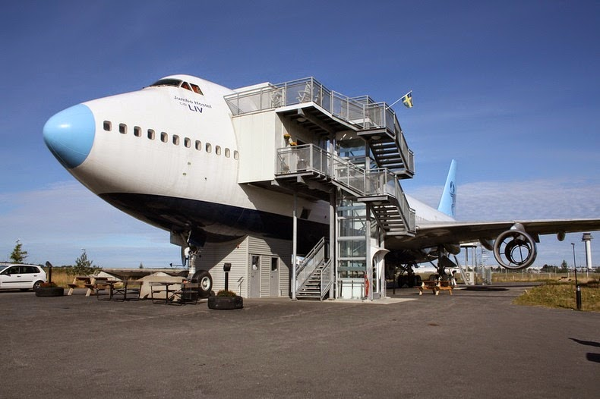

On a disused runway at Arlanda Airport near Stockholm, in Sweden stands a decommissioned 747-200 jetliner. After having served numerous airline companies around the world, the airplane was towed into the tarmac in 2008 for one last time. The plane wasn’t refueled and no ground staff checked the tire pressure. Instead, it was placed on a concrete foundation and the landing gear was secured in two steel cradles, for the 747 was to serve the rest of its life as a hotel.
Jumbo Hostel can be reached by a 15-minute walk from the main terminal or via a five-minute shuttle bus. The hostel is equipped with a budget dormitory, a couple of twin and three-bed combo rooms with shared shower and toilet and a luxury suite in the converted cockpit that offered a panoramic view of the airport.
To build the hotel and accommodate all the beds, the plane was stripped down to its shell. All the seats were removed and the plane was sanitized completely. The hostel was built like any building, subjected to the same demands on climate control and insulation […]
Source : https://www.amusingplanet.com/2014/11/jumbo-hostel-stockholms-airplane-hotel.html

………………………………………………………………………………………………………………………………………………………………………………………………………………………………………………………………………………………………………………………………………………………………………………………………………………………………………………………………………………………………………………………………………………………………………………………………………………………………………………………………………………………………………………………………………………………………………………………………………………………………………………………………………………………………………………………………………………………………………………………………………………………………………………………………………………………………………………………………………………………………………………………………………………………………………………………………………………………………………………………………………………………………………………………………………………………………

Partie 3 : Expression écrite

Consigne :
Vous traiterez, en anglais et en 100 mots minimum, l’un des deux sujets suivants, au choix.

Sujet 1 : What would be your dream hotel? Give details about the place, the concepts, the available services and activities etc.

OU

Sujet 2 : You are thinking of opening a new bar hotel or restaurant with an original concept. Present your project (name, place, prices, services, decoration etc.)

………………………………………………………………………………………………………………………………………………………………………………………………………………………………………………………………………………………………………………………………………………………………………………………………………………………………………………………………………………………………………………………………………………………………………………………………………………………………………………………………………………………………………………………………………………………………………………………………………………………………………………………………………………………………………………………………………………………………………………………………………………………………………………………………………………………………………………………………………………………………………………………………………………………………………………………………………………………………………………………………………………………………………………………………………………………………
…………………………………………………………………………………………………………………………………………………………………………………………………………………………………….

